Instructions for Preparing Camera-Ready Abstracts for NNBAC2024
(Paper Title：Times, 12 points, Bold, Align left.)

First Author 1⁺, Second Author 2, Third Author 3*, ... nth Author
(Author：12 points, Times, Bold.
The presenter is specified with a cross ⁺. The corresponding author is specified with an asterisk * .)

1⁺ Department of Mechanical Engineering, National Institute of Technology, Niihama College, Ehime, Japan
2 Department of Materials Science, National United University, Miaoli, Taiwan
* E-mail: corresponding_author@nuu.edu.tw
(Affiliation：Times, 12 points.)

Authors should prepare one-page camera-ready abstracts using this template file, which will be published as an online Abstract Book in the same size. The abstract page should have margins of 30 mm in the A4 size.
Abstract should clearly describe background, objective, method, and significant results and conclusions. [1] The page length must be one page including figures or tables. [2] Abstract may contain up to two figures or tables.
The abstracts should be uploaded to the designated location on Microsoft Teams with the MS-Word file and the PDF file. Detailed instruction will be provided on the web page.
(Abstract body: Times, 12 points.)
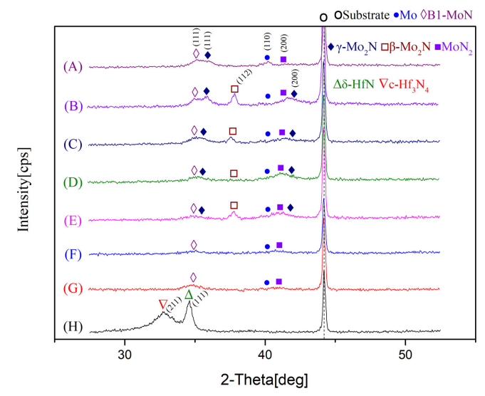
Table 1: Sample table for abstract preparation.
(Table：Times, 10 points.)

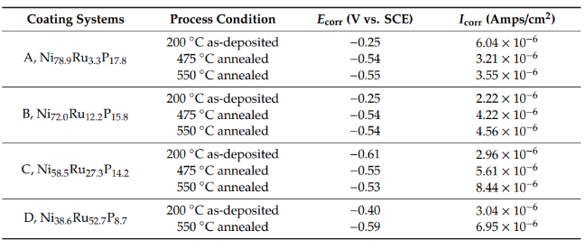

Fig. 1: Sample figure for abstract preparation. (figures：Times, 10 points.)

Keywords: Keyword1, Keyword2, Keyword3 …(max 6 Keywords)
(Keywords：Times, 12 points.)

[1] Author, A. A., Author, B. B., & Author, C. C. (Year). Title of article. Title of Periodical, xx(xx), xxx-xxx. doi: xx.xxxxxxxxxx
[2] Author, A. A. (Year). Book title. Location: Publisher.
(Times, 10 points.)

